SIN WAVE OUTPUT DATA:
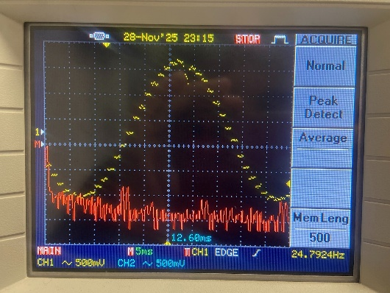  25 HZ | 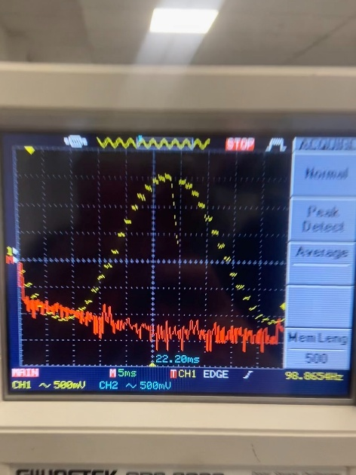  100 Hz | 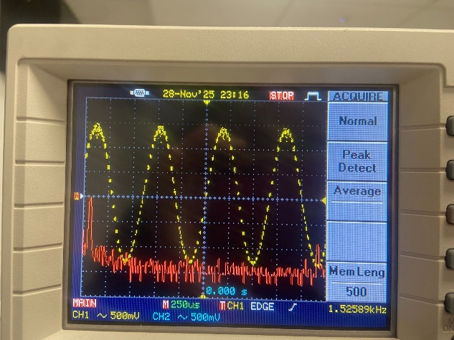  1.5 KHZ
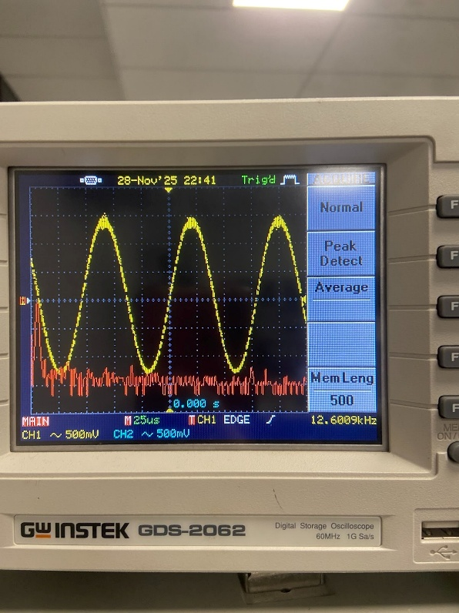  12.5 KHZ | 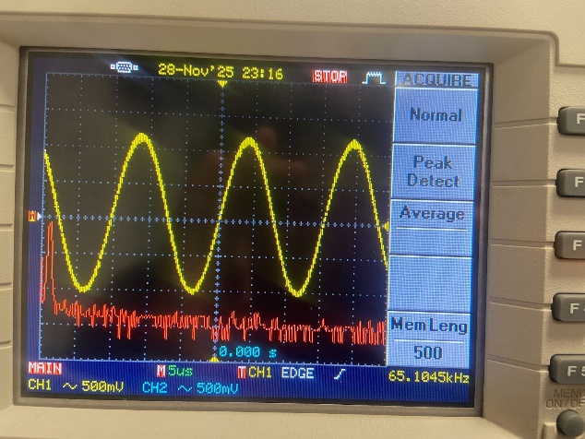  65 KHZ

PWM WAVE OUTPUT DATA:
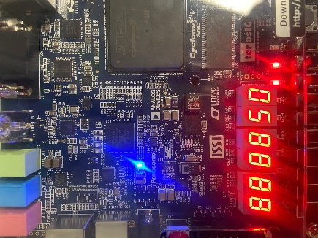  50% DUTY CYCLE SSEG  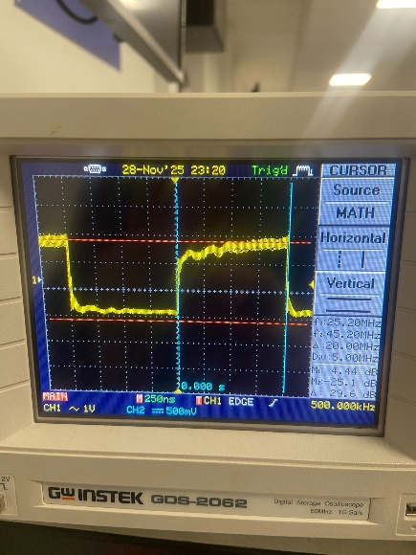  50% DUTY CYCLE PWM WAVE | 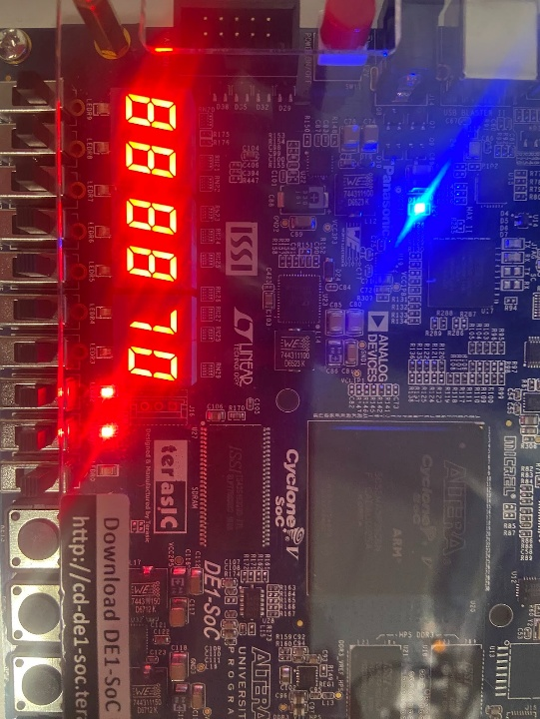  70% DUTY CYCLE SSEG  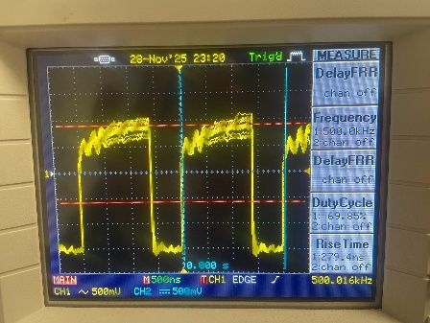  70% DUTY CYCLE PWM WAVE | 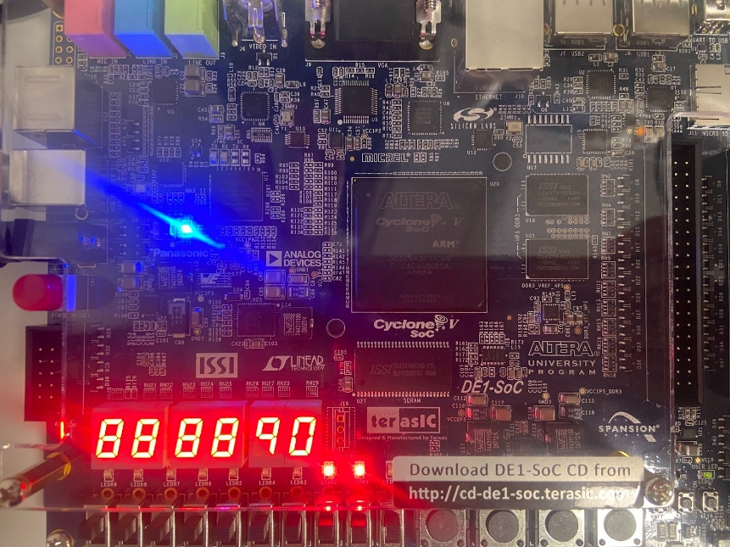  90% DUTY CYCLE SSEG  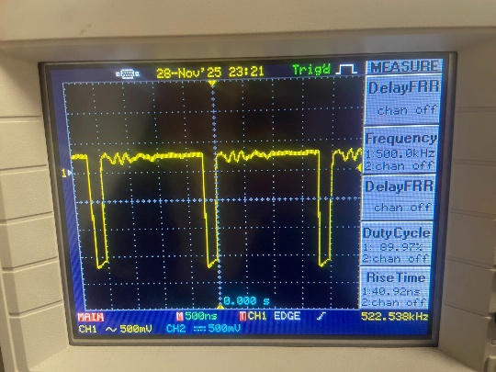  90% DUTY CYCLE PWM WAVE
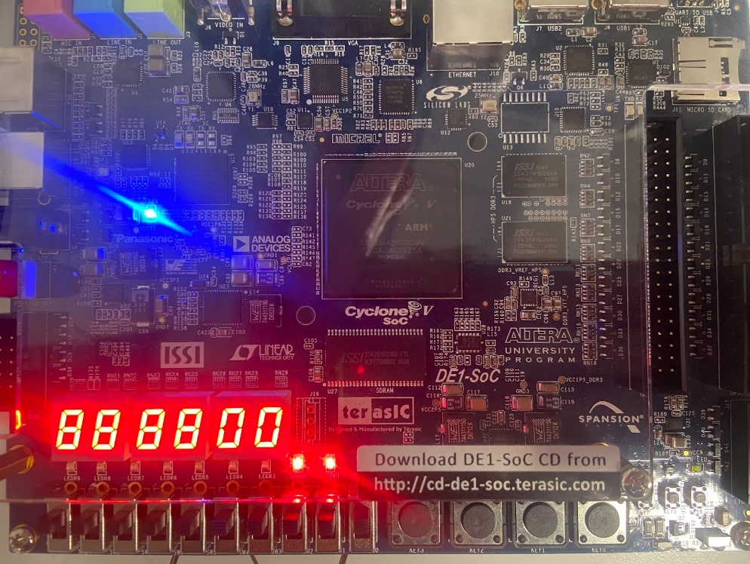  0% DUTY CYCLE SSEG  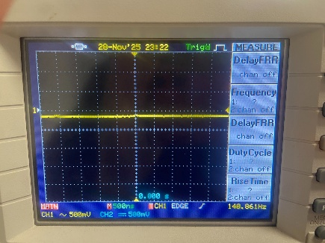  0% DUTY CYCLE PWM WAVE | 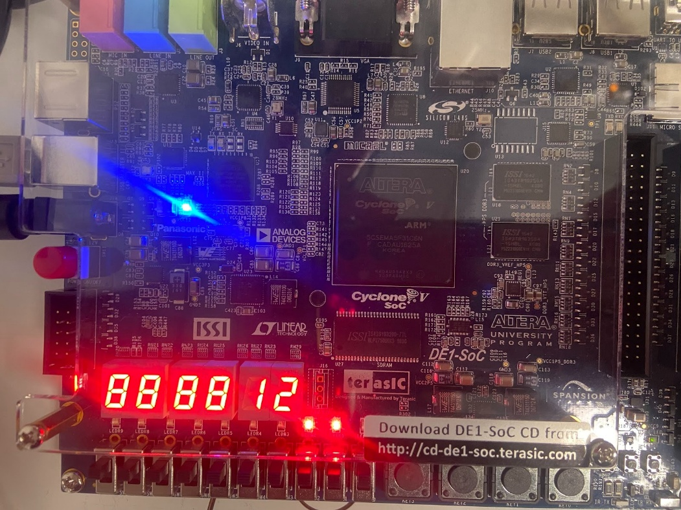  12% DUTY CYCLE SSEG  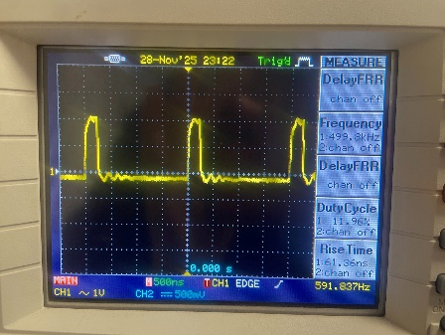  12% DUTY CYCLE SSEG

